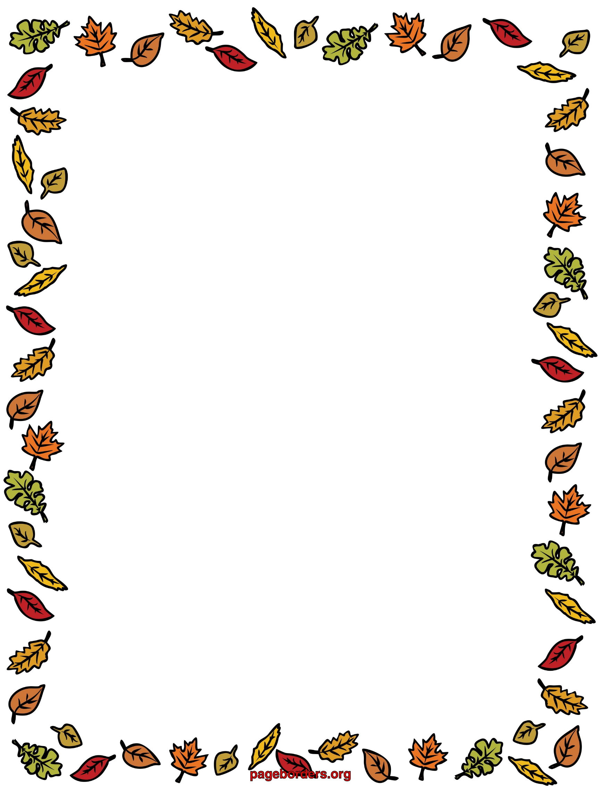

Crownpoint Elementary School

~Thanksgiving Spirit & Native American Heritage Appreciation Week~

November 18-22, 2024

**Monday: Pajama Day**

*(Wear your favorite warm pjs.)*

**Tuesday: Indigenous Day**

*(Wear your Indigenous Attire: Moccasins, Hair-Bun, Jewelry, or Clan/Indigenous Graphic shirt.)*

**Wednesday: “Fall Colors” Day**

*(Dress up in Fall colors like orange, brown, yellow, & red!)*

**Thursday: Superhero Day**

*(Dress up like a Superhero or wear your favorite shirt.)*

**Friday: Traditional Dress Day**

(Wear your best Traditional outfit.)